
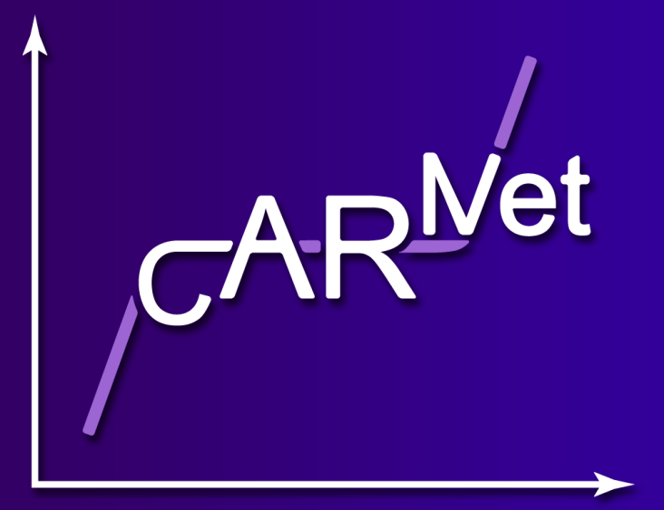

The 5th International Meeting on
Cerebral Haemodynamic Regulation (CARNet)

Monday 13th & Tuesday 14th July 2015, Chilworth Manor Hotel

POSTERS

Physiology
1 | Static and dynamic cerebral autoregulation – are we measuring the same thing?  D. L. K. de Jong, Radboud University , Nijmegen, The Netherlands
2 | Multimodal measurements of blood pressure and cerebral hemodynamic responses to hypercapnia in the MRI  T. Myllylä, University of Oulu, Oulu, Finland
3 | Are hormonal changes throughout the menstrual cycle associated with changes in cerebral autoregulation?  M. Favre, Rutgers Biomedical Health Sciences, Newark, NJ, USA
4 | Cerebrovascular responsiveness to carbon dioxide in atrial fibrillation  I.D. Braz, University of Birmingham, UK
5 | Influence of carbon dioxide on dynamic cerebral autoregulation during head-down tilt  T. Kurazumi, Nihon University, Japan
6 | Dopamine infusions improves cerebral autoregulation in newborn piglets  V. Eriksen, Copenhagen University Hospital, Denmark
Technical
7 | Measuring blood pressure oscillations in the MRI  D. L. K. de Jong, Radboud University , Nijmegen, The Netherlands
8 | Neurovascular Coupling and the BOLD signal  T. David, University of Canterbury, New Zealand
9 | Prospective comparative clinical study of non-invasive cerebrovascular autoregulation monitor  V. Petkus, Kaunas University of Technology, Lithuania
10 | A new index of dynamic cerebral autoregulation applied to the sit-to-stand maneuver  M. Chacon, University of Santiago de Chile, Chile
11 | Time varying estimates of dynamic cerebral autoregulation at rest  R Panerai, University of Leicester, UK
12 | Can critical closing pressure replace EtCO2 as a determinant of CBFV in multivariate models?  F.A. Bello Robles, Universidad de Santiago de Chile, Chile, CITIAPS
13 | Controlling for heart rate variability improves the estimation of cerebral autoregulation and vasomotor reactivity in older adults and MCI patients  V. Marmarelis, University of Southern California, Los Angeles, USA
Clinical
14 | Absence of spontaneous blood pressure variability in patients after out-of-hospital cardiac arrest during the post-cardiac arrest syndrome.  J.M.D. van den Brule, Radboud University Nijmegen Medical Centre, the Netherlands
15 | The relationship between BP variability, white matter lesions and frailty in Alzheimer’s disease patients  G. van Spijker, Radboud University Nijmegen Medical Centre, the Netherlands
16 | Acute stages of sport concussion: heart rate variability and blood pressure suppression during postural hemodynamic drives  J P Neary, University of Regina, Canada
17 | Dynamic cerebral autoregulation in patients with hypertension  R. Nogueira, University of São Paulo School of Medicine, São Paulo, Brazil
18 | Cerebral Hemodynamics in thrombolysis for acute ischemic stroke: a systematic review and meta-analysis  R. Nogueira, University of São Paulo School of Medicine, São Paulo, Brazil

